**Lesson 2 – Critical Thinking**

**Agenda:**

* Thinking and critical thinking
* Criticism and critical thinking
* Powerful techniques to think critically

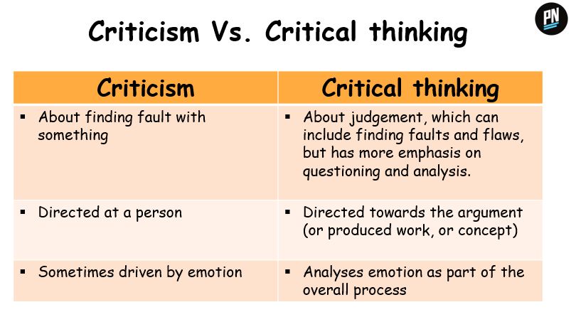

**Thinking and critical thinking**

**Thinking** is the process of using your mind to consider something carefully.

**Critical thinking** is the process of thinking that involves analytic evaluation of a situation or the careful application of reason in the determination of whether a claim is true.

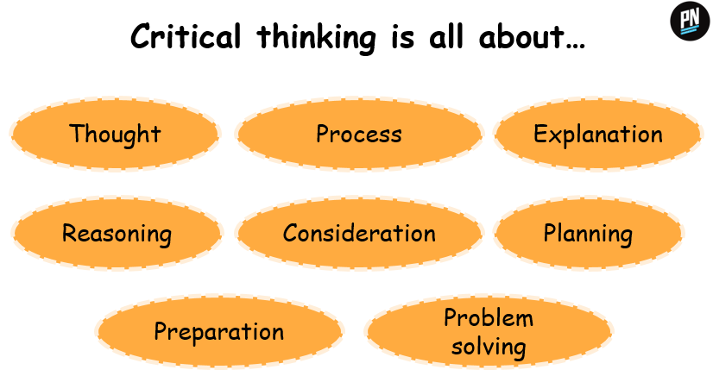

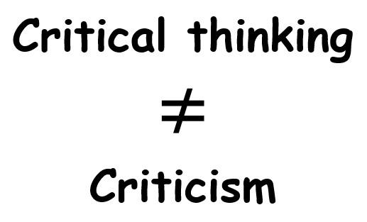

**With Critical Thinking, you can…**

* Perform better
* Achieve more
* Enhance creativity
* Outperform others with your efficient critical thinking and problem solving skills
* Question what you are told

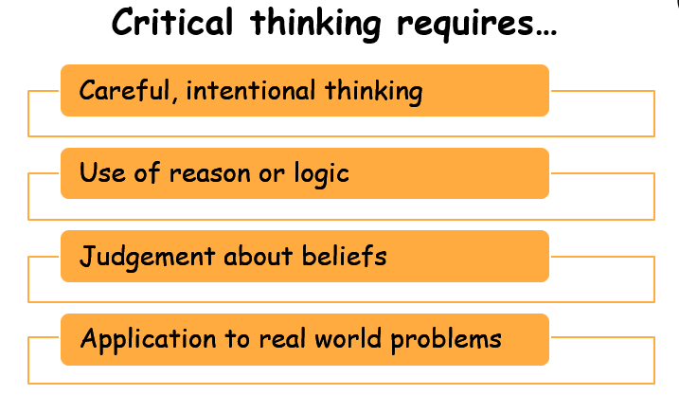

**Powerful techniques to think critically**

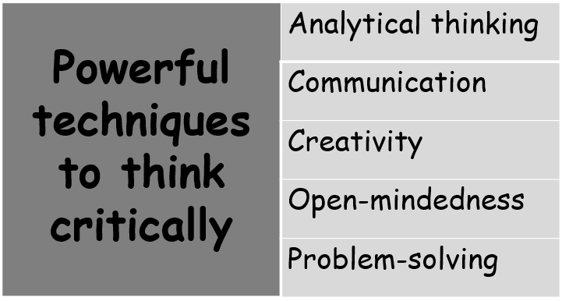

**Analytical thinking** is the gathering and breaking down of information into small bites that help make sense of it.

***To use Analytical thinking:***

* Be very clear on *why* you need the information
* Gather information from as many sources as you can
* Break down the data into factual subsets and relate each to the issue
* Think on paper to make new connections

**Communication** is a key technique for critical thinking as it gives you access to the thoughts of people around you.

* Ask for different points of view and seek justification for the same thing
* Listen without interrupting and only ask questions
* Paraphrase the speaker/writer’s point of view and ask for affirmation
* Observe actively

**Creativity**

To really learn **critical thinking**, you need to include **elements of creativity** in the process.

* Brainstorm idea with your team
* Gather data and tabulate it in the form of mind map
* Play brain games
* Learn new skills

**Open-mindedness**

* Be brutally honest about your strengths and weaknesses
* Hear an opinion that conflicts with your own without forming a response before the opinion is fully voiced
* Acknowledge that there may be more than one approach to solve a problem and that they may all be right in some way
* Consider your true feelings when you will implement any required changes

**Problem-solving**

Critical thinking is heavily dependent on **problem-solving**.